**Final Assignment Part I**

Jianghong Man

MSCA 31015 1 Data Science for Consulting

1. **Data visualization (more steps are in the Jupyter Notebook)**

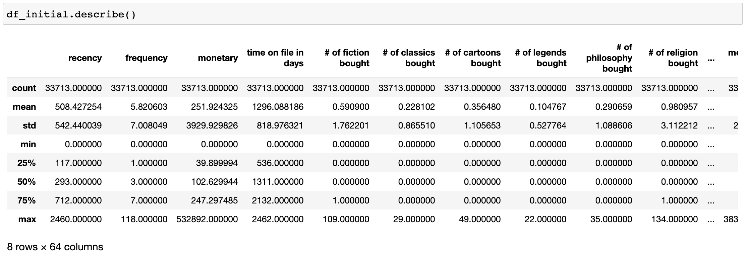

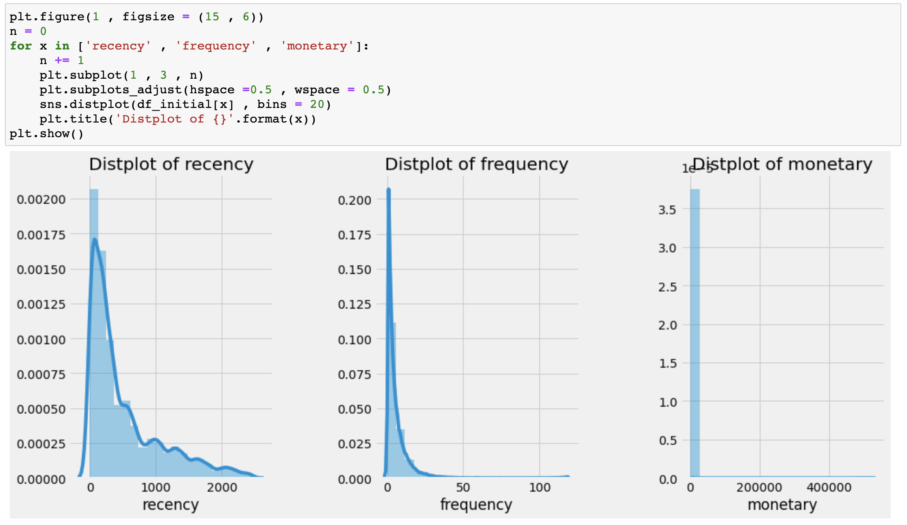

1. **Save data to new data set with more descriptive labels**

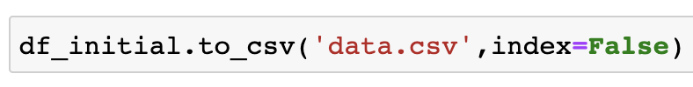

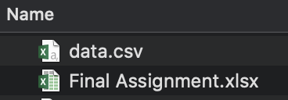

1. **SMART Goal:** 
   1. Specific: Increase the total user clicks of the same category books by 10%-15% per month. Increase the average number of books customers bought in each category by 1-2 books per month. Increase the average revenue of books in each category by $50.
   2. Measurable: Increase the size of each purchase per customer by 1-2 books. Increase the total transaction size of the website by 8%-10% per month. Increase revenue by 10%-12% per month. Expect an annual growth rate of 10%
   3. Actionable:
      1. Loyal Customers - Reward system should be given to loyal customers (who frequently bought books online) by way of discount/coupons on new recommended books calculated by the system at intervals after they buy new books.
      2. Customer reviews - The online bookstore can ask customers to write reviews of books they read and post them online with or without spoiling (the book store should have sections that let readers choose whether they wrote something related to the actual content of the book or not). It is one of the top ways to attract more customers and garner sales.
      3. Marketing exposure – In order to attract new readers, the website should use current customers wisely to advertise the website. Each registered reader should have his or her own code. If he or she recommend this website to other users referring to the unique code, both the new customer and old customer will have a discount on the next purchase.
   4. Relevant: Discussion with the client and make sure the “Specific”, “Measurable”, and “Actionable” list made above achieves the original intent of the goal.
   5. Timebound: Took specific actions above and expect an increase in the monthly growth rate of 8%, increase each category sales by 3% in one month. Also, keep on track of the numbers in order to get the ultimate goal within the next year.
2. **We have 6 people in our consulting group, which includes:**
   1. Website Analyst
      1. Work with the technical team to establish best practices for testing software
      2. Discuss the customer experience and behavior with the marketing team
      3. Plan, develop and manage web and mobile campaign and channel tracking
      4. Produce reports for the Management team
   2. Data Scientist:
      1. Create new, experimental frameworks to collect data
      2. Develop models to make recommendations of books
      3. Correlate similar data to find actionable results
   3. Data Visualization Specialist:
      1. Make large and complex data more accessible, understandable, and usable
      2. Improve and integrate data, data federation
      3. Deliver the data in a useful and appealing way to users
   4. VP Marketing
      1. Develop and implement a cohesive marketing plan to increase brand awareness
      2. Set current and long-term goals for internal teams
      3. Design and review the Marketing department’s budget
      4. Prioritize marketing projects and allocate resources accordingly
   5. Customer Research Analyst/Customer Satisfaction Manager
      1. Assist customers via phone, email, and chat regarding placing orders, order confirmation, product/promotion questions, shipping status, returns
      2. Work directly with customers to resolve order-related issues.
      3. Works closely with manager to improve customer service-related operations.
   6. Ecommerce Financial Manager
      1. Monitor the day-to-day financial operations within the company (payroll, invoicing, and other transactions)
      2. Prepare monthly and quarterly management reporting
      3. Participate in strategic data analysis, research, and modeling for senior company leadership
3. **Team strength and discipline focus areas:** 
   1. Our team is formed with 6 specialists:
      1. We have Zoila, who studied Psychology and MIS in college. She is the Customer Satisfaction Manager in our team, who possesses great communication skills. With her major, she understands what customers require. She is also confident, patient, polite, and tactful when dealing with difficult situations.
      2. We have Maggie, who worked at an investment banking for 2 years. She is the Ecommerce Financial Manager in our team. She has strategic planning experience at the management level before and she demonstrates strong creative and critical thinking skills.
      3. We have Meenu, who has experience in fort end dev and coding background. She is the data scientist on the team. She is a professional in statistics, Python, data extraction, data wrangling, and data exploration. She also understands machine learning algorithms and big data processing frameworks.
      4. We have Nimo, who majored in finance and MIS in college but have great experiences in CS. She is the data visualization specialist on the team. She has excellent analytical skills and the ability to work with large amounts of information and see the ‘bigger picture’. She is also comfortable with juggling facts, figures, and number crunching.
      5. We have Beca, who was in business school before. She is the VP of Marketing on the team. She has outstanding communication, presentation, and leadership skills. She also has in-depth knowledge of market research
      6. We have Teresa, who has coding expense before. She is the website analyst on the team. She has strong business acumen, the understanding of traffic drivers, and communication skills.
   2. With specialists in different areas, we can form a well-functioning team and solve business problems.
4. **K-Means clustering (details in Jupyter Notebook)**

